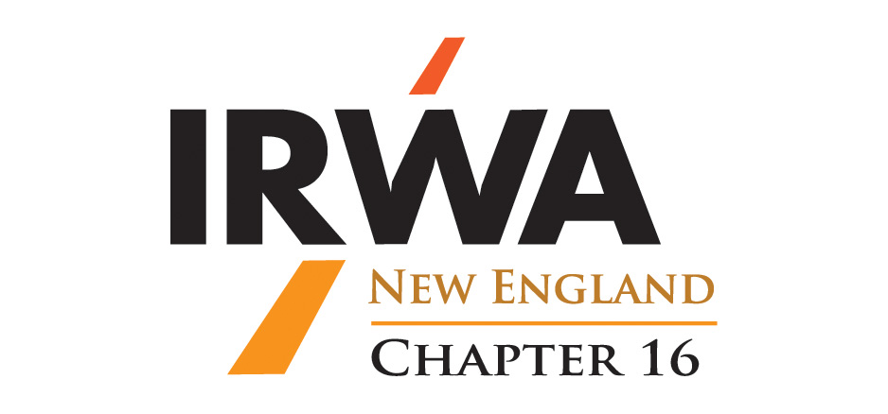

**Chapter 16 General Meeting Minutes**

Friday, January 11, 2019

Fratello’s

Manchester, New Hampshire

*In Attendance:*  Trish Morrison, President; Ben Sprague, Vice President; Betsy Bosiak, Secretary; Patty Quinn; Rick Pino; Kevin Arsenault; Scott LaChance

*Guests:* Steve Cleary

Ben called the meeting to order welcoming everyone present BS GUEST Steve Cleary.

1. **Secretary’s Report Betsy Bosiak**

The following secretary’s reports were reviewed

General Meeting of May 17, 2018 – Ben motioned to approve the minutes of May 17, 2018, Alley seconded the motion. The motion passed.

E-Board Meting of June 7, 2018 – Ben motioned to approve the minutes of June 7, 2018, Scott seconded the motion. The motion passed.

E-Board Meeting of September 6, 2018 – Patty motioned to approve the minutes of September 6, 2018, Trish seconded the motion. The motion passed.

E-Board Meeting of October 17, 2018 – Scott motioned to approve the minutes of October 17, 2018, Ben seconded the motion. The motion passed.

E-Board Meeting of December 14, 2018 – Scott motioned to approve the minutes of December 14, 2018, Patty seconded the motion. The motion passed.

1. **Old Business Ben Sprague**

Patty requested to have certification forms sent out for the Forum attendees to receive continued education for attending. Ben will have this completed.

1. **Treasurer’s Report Ashley Emerson**

There was no Treasurer’s Report. Ashley would like to resign from this position with Trish indicating that Chip Johnson being willing to take the position until May elections.

Trish motioned to appoint Chip Johnson as interim treasurer, Ben seconded the motion. The motion passed.

Rick will reach out to Mike McParland to assist with the transition.

1. **Committee Reports:**
2. Committee on Nomination and Awards **Vacant**

Patty noted that candidates for International and National Awards have to be submitted by February 1. The chapter does not have any nominations for these awards.

Rick and Scott volunteered to be the Nomination and Awards Committee.

1. Professional Development Committee **Lara Bailey, Chair**

As Lara was not present there was no report for this committee.

1. Education Committee **Patty Quinn, Chair**

Patty noted that NHDOT has requested to hold Courses 213 and an 800 Course. It was noted that Course 213 is required for certifications. Ben will coordinate the courses.

It was discussed to hold Course 431 in the Fall. Rick is able to instruct this course.

Patty will work to coordinate courses with other chapters.

No one was sure if Courses 421 and 218 have been reconciled.

1. Membership Committee **Betsy Bosiak, Chair**

(Two vacancies)

Betsy had a list of unpaid members to date. She and Ben will reach out to these members to be sure they renew soon.

Betsy had 4 certificates for new members, they were not present. Ben will give the members their certificates.

1. Communications Committee **Ally Brown, Chair**

Ally noted that it has been quite since the Forum. She and Ben will work on a Newsletter.

1. Young Professionals Committee

There was no report from this committee.

1. Electric & Utilities **Sandy Fogg, Chair**

There was no report from this committee.

1. Local Public Agencies **Carolann McCarron, Chair**

There was no report from this committee.

1. Oil & Gas Pipelines **Lara Bailey, Chair**

There was no report from this committee.

1. Transportation

There was no report from this committee.

1. **Region/International Committees**

Patty mentioned that she was a member of the IEC. She noted the elections at the Annual Conference and upcoming elections at the 2019 Annual Conference.

Trish and Patty will attend the Portland Conference.

The date by which chapter directors have to be appointed was discussed. Ben will research this.

Potential attendees to the Spring Forum are Scott, Rick. Patty and Trish.

1. **Calendar of Meetings:**
2. February 8, 2019 – E-Board: Will be a teleconference meeting
3. March 8, 2019 – General Membership: Portland Water District, Portland Maine – Speaker TBD (Patty and Trish will arrange for a speaker)
4. April 12, 2019 – E-Board – Ben will host
5. May 10, 2019 – General Membership: Annual meeting (Elections) – NHDOT - Speaker TBD
6. **Other Business**

Kevin Arsenault will Chair the Engineering and Survey Committee.

Rick noted the chapter should have representation on the relocation and valuation committees.

Ben noted that Derrick is willing to do a presentation on the Young Professionals at an upcoming meeting.

Ben adjourned the meeting.

Respectfully submitted,

Betsy Bosiak, Secretary